Libman Education – Training the Healthcare Workforce July 6, 2019

Q & A with Dr. Z
by David Zielske, MD, CIRCC, COC, CCVTC, CCC, CCS, RCC
Question: WavelinQ System
We have implanted a WavelinQ device but are not sure how to code this procedure. There is a supply C-code available, but we don’t know which CPT code to use.
Answer:
The WavelinQ is fairly new technology for creating an AV dialysis fistula. It requires separate percutaneous venous and arterial access and uses two catheters with a built in magnet to position the catheters. RF energy is then used to create the fistula.
The C-code you refer to as a supply code is probably the procedure code. The procedure is reported with HCPCS level II code, C9755, with a national APC payment of $9,669.04. This code became effective on 1/1/2019. Payment at an ASC is about half as much as APC payment. For physician billing, there is no specific code. Physicians report unlisted code 37799 for the procedure.
Another new method for AV fistula creation uses the Ellipsys device, which is reported with code C9754.

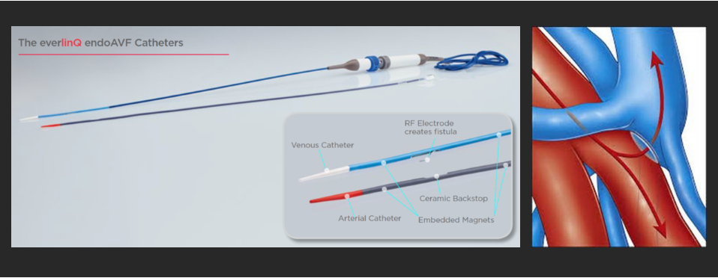
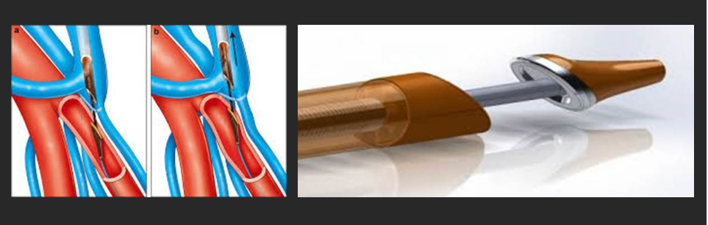

About the Author
David Zielske, MD, CIRCC, COC, CCVTC, CCC, CCS, RCC
David Zielske is founder and President of ZHealth Publishing and primary author and editor of ZHealth publications. Dr. Z practiced as an interventional radiologist and has over twenty years experience as a coding reviewer and coding expert. He is Board Certified in Radiology and has functioned as an independent interventional radiology, vascular surgery, and cardiovascular coding consultant to a variety of physician groups and hospital providers across the country. He also served as an instructor for over 200 coding seminars.

